1. Agenda:
   1. We will configure Kafka Consumer to handle Deserialization Error.
2. 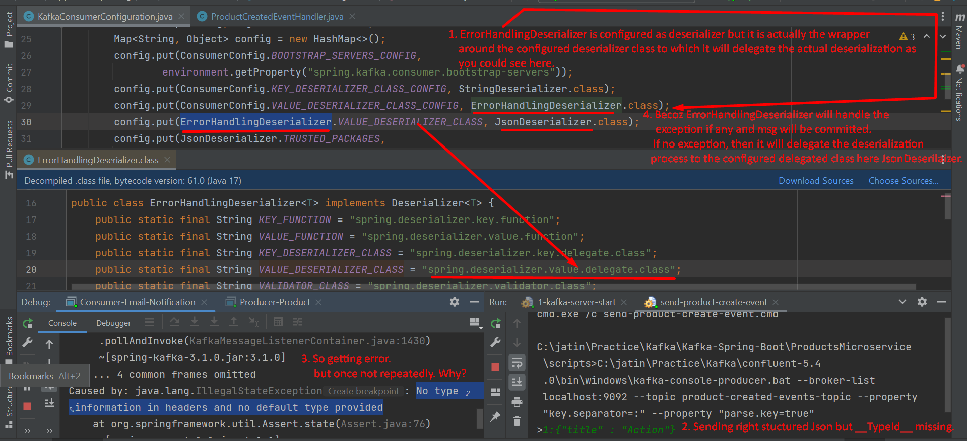
3. **NOTE**: Jatin -> Retry is performed only after msg marshalling is done successfully and exception occurs later on.